**Project Title:** CraigsList

**Website Name:** ProjectCraigslist

**Project Description:** Craigslist is a classified advertisements website.

Any common user will be able to view all the available products on sale and search or filter the results with description or pricerange. He can select any product to view its details along with the seller`s contact information.

Any Registered user can also view available products and their details with search and filter options. In addition, he can post an advertisement to sell a product and view the history of sold and unsold items in this selling cart. He can update any of his listings as sold which will remove the item from the available product listings.

There is no need for admin user as any registered user can add and update items.

**Database Design:**

**Database Name: `craigslist`**

**Table structure for table `user`:**

CREATE TABLE IF NOT EXISTS `user` (

`user_fname` varchar(80) DEFAULT NULL,

`phone` varchar(80) DEFAULT NULL,

`user_id` varchar(80) NOT NULL DEFAULT '',

`email` varchar(80) DEFAULT NULL,

`user_password` varchar(400) DEFAULT NULL,

PRIMARY KEY (`user_id`)

) ENGINE=InnoDB DEFAULT CHARSET=latin1;

**Table structure for table `category`:**

CREATE TABLE IF NOT EXISTS `category` (

`category_id` int(11) NOT NULL,

`category_name` varchar(30) DEFAULT NULL,

PRIMARY KEY (`category_id`)

) ENGINE=InnoDB DEFAULT CHARSET=latin1;

**Table structure for table `product`:**

CREATE TABLE IF NOT EXISTS `product` (

`prod_id` int(5) NOT NULL AUTO_INCREMENT,

`title` varchar(40) NOT NULL,

`user_id` varchar(80) NOT NULL,

`email` varchar(50) NOT NULL,

`category` int(11) NOT NULL,

`price` float NOT NULL,

`img_desc` varchar(40) NOT NULL,

`phone` varchar(15) DEFAULT NULL,

`prod_desc` varchar(70) DEFAULT NULL,

`Name` varchar(60) NOT NULL,

`sold_Flag` varchar(10) NOT NULL,

PRIMARY KEY (`prod_id`)

) ENGINE=InnoDB DEFAULT CHARSET=latin1 AUTO_INCREMENT=4021 ;

**Table structure for table `** **producthistory`:**

CREATE TABLE IF NOT EXISTS ` producthistory` (

`user_id` varchar(40) NOT NULL,

`isbn` int(5) NOT NULL AUTO_INCREMENT,

PRIMARY KEY (`isbn`)

) ENGINE=InnoDB DEFAULT CHARSET=latin1 AUTO_INCREMENT=4021 ;

**Languages/frameworks used:**

For server side scripting: PHP

For client side scripting: Bootstrap.

**Screenshots:**

Home: (All Product Listings)

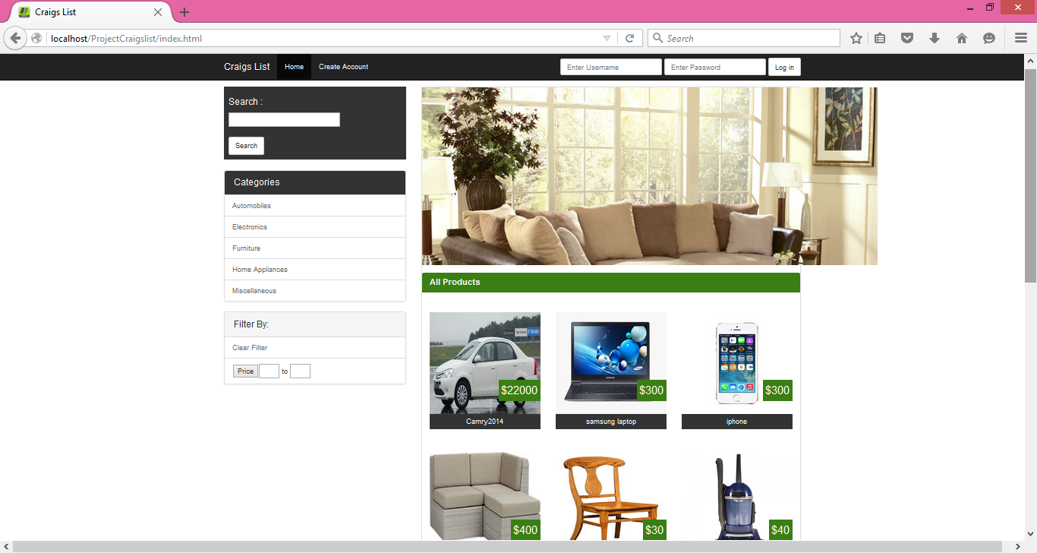

Filter By Categories:

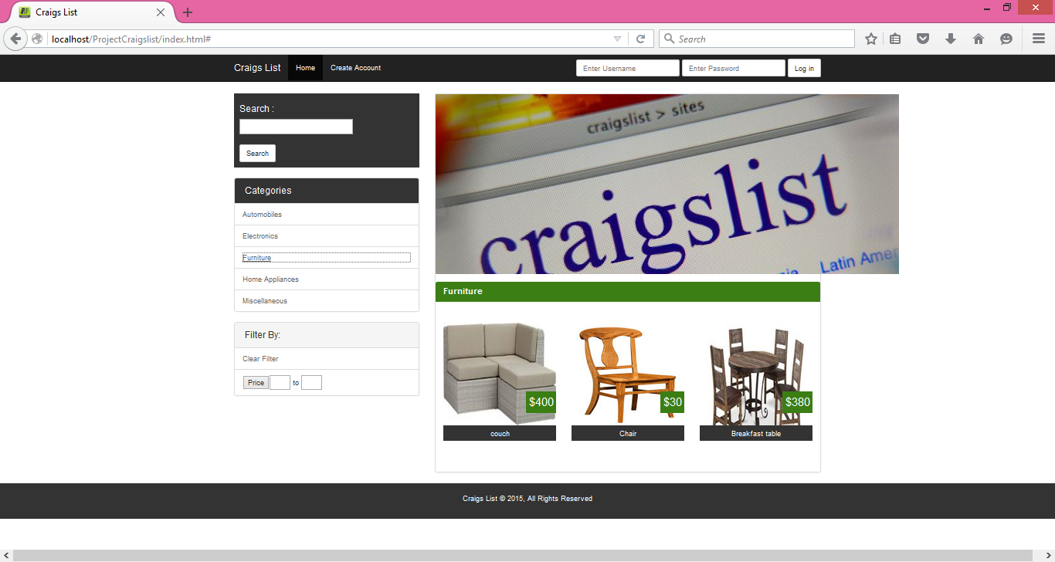

Filter By Categories:

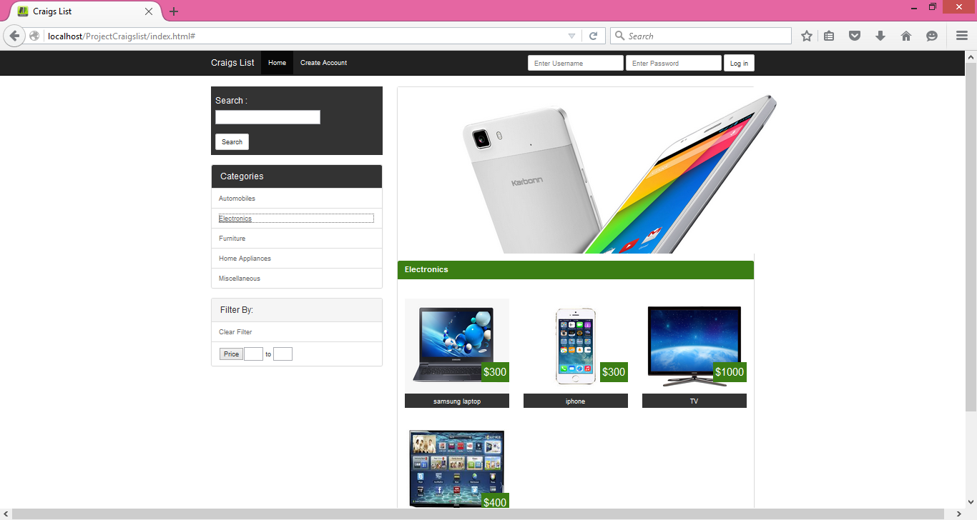

Search:

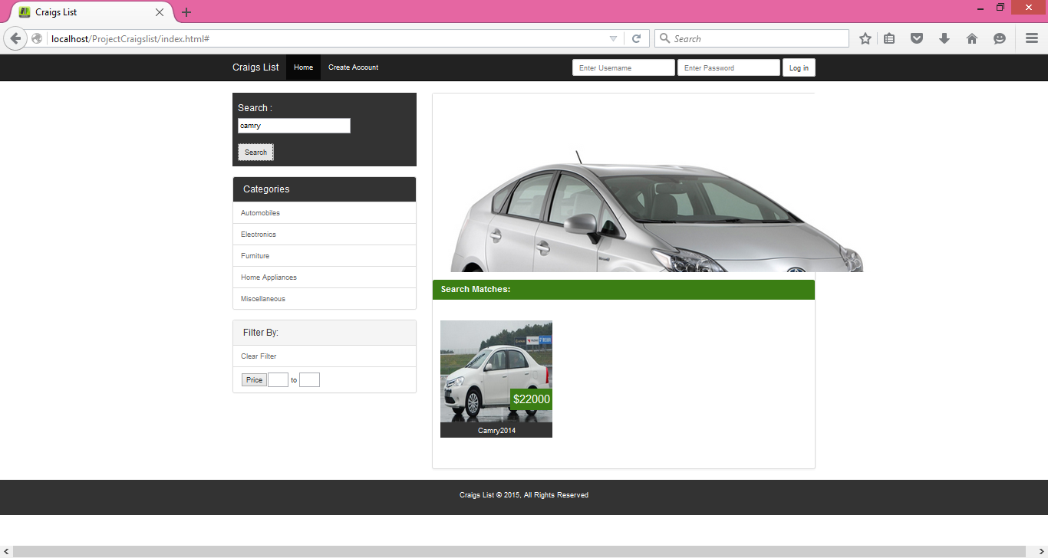

Filer by Price Range:

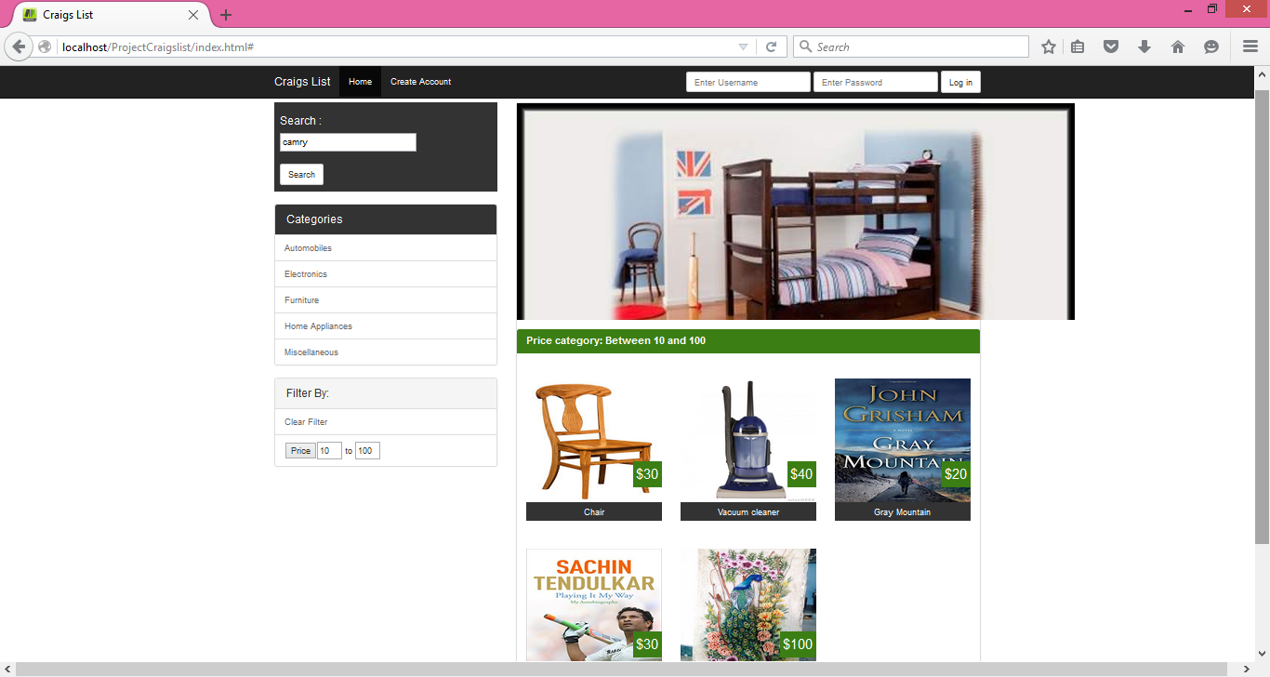

Create Account: (with Validations)

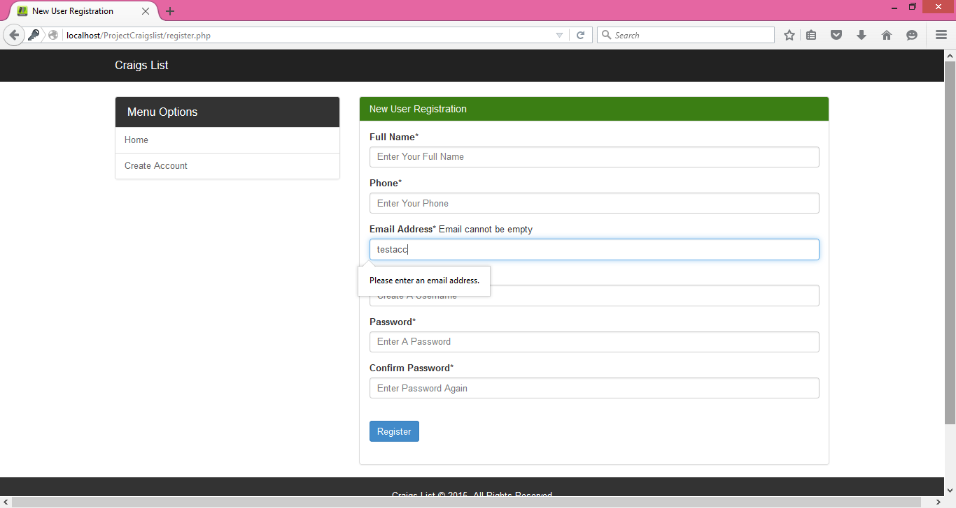

Login:

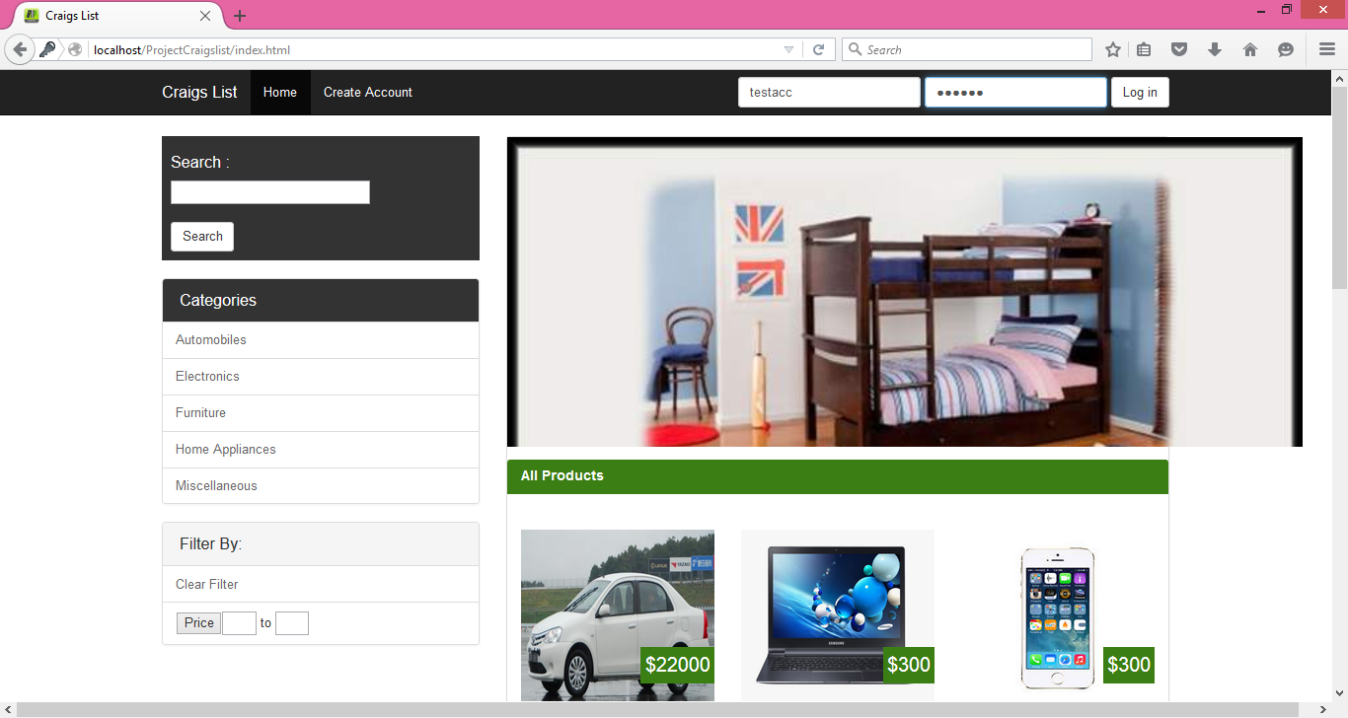

Home Page (after logging in):

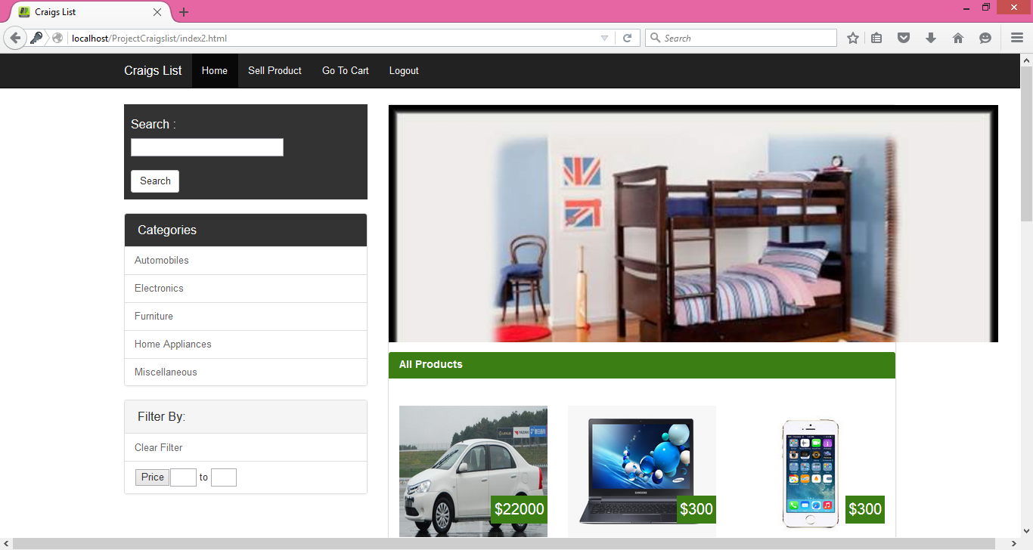

Sell Product:

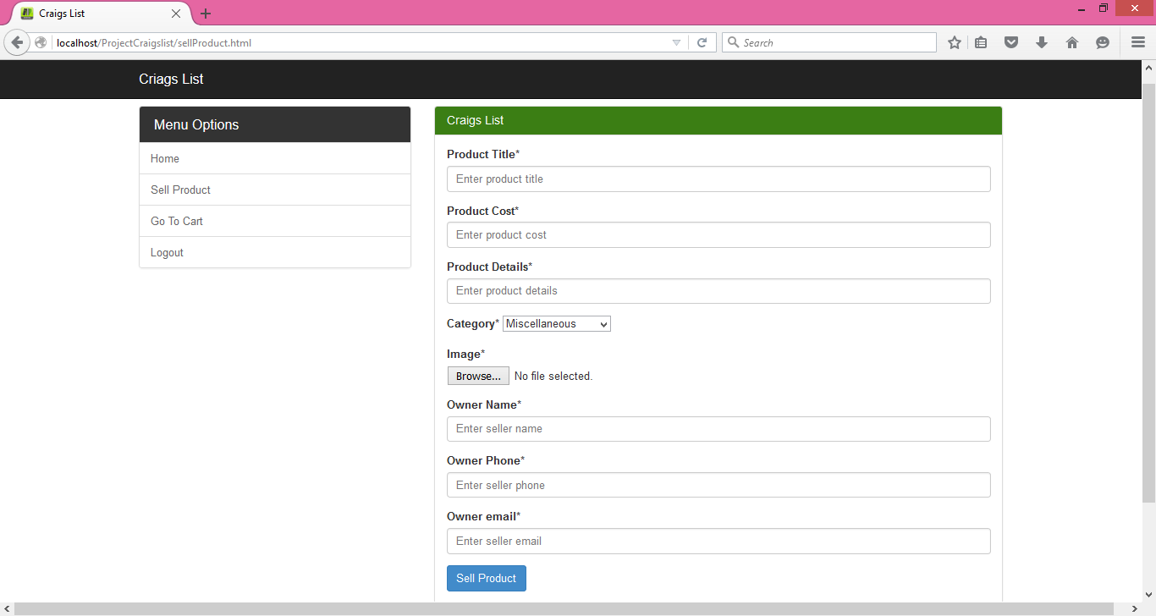

Image Upload:

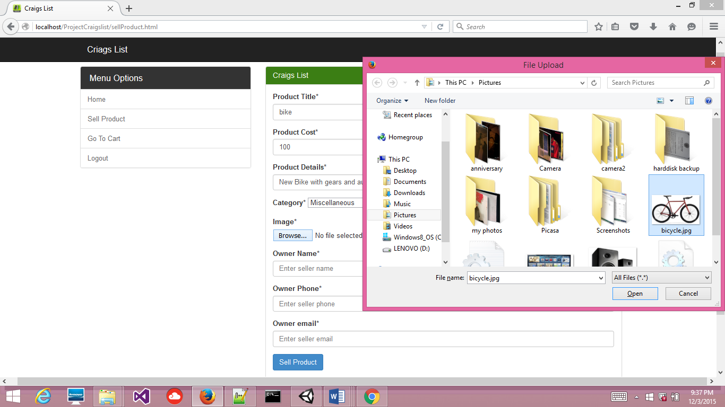

Selling Cart:

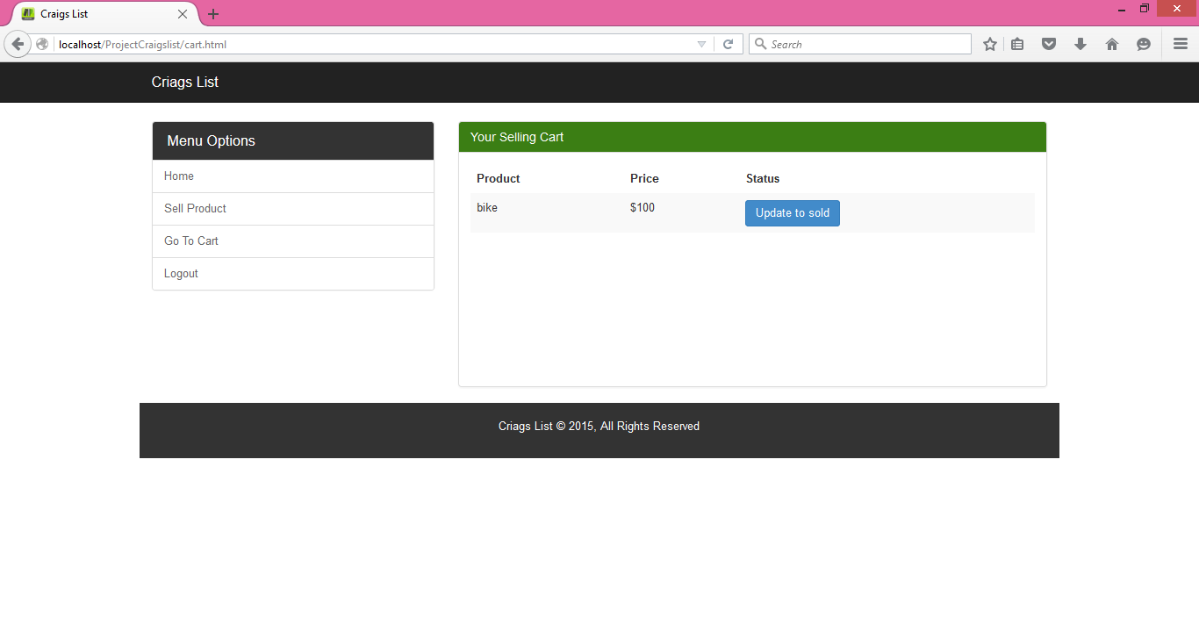

Product Listings(Home):

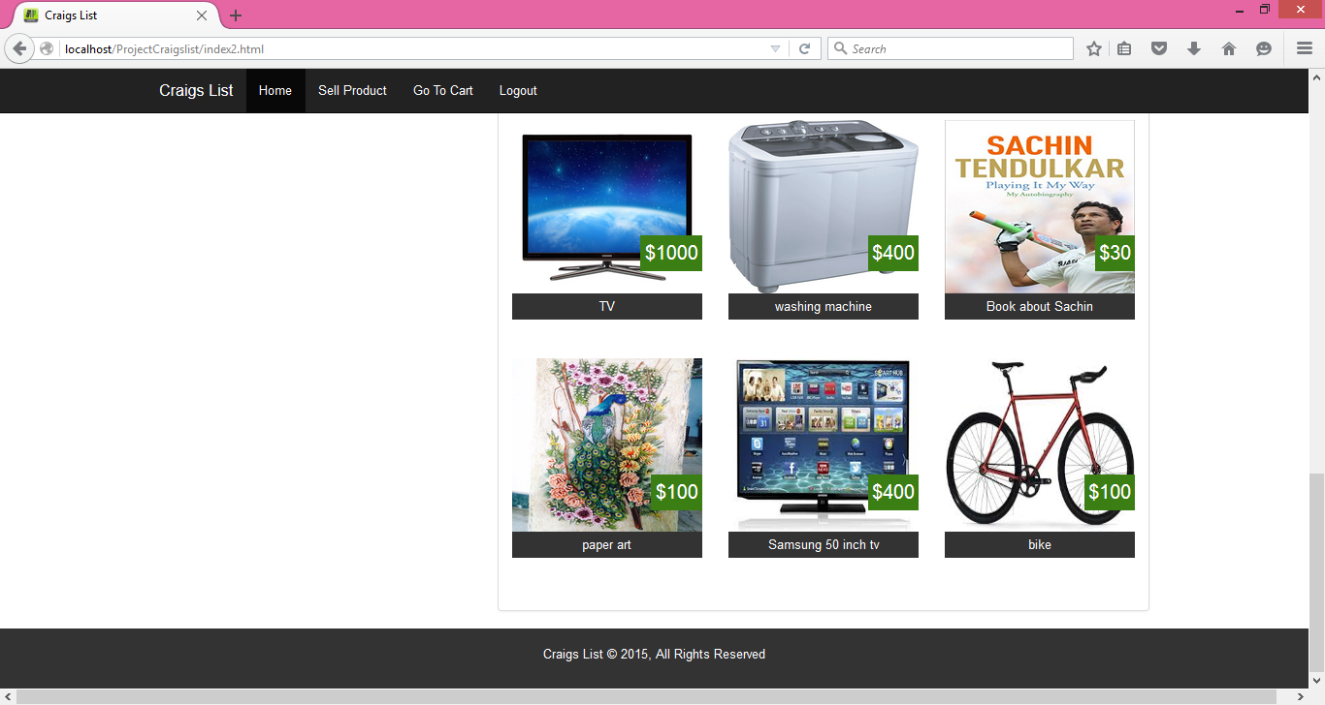

Product details:

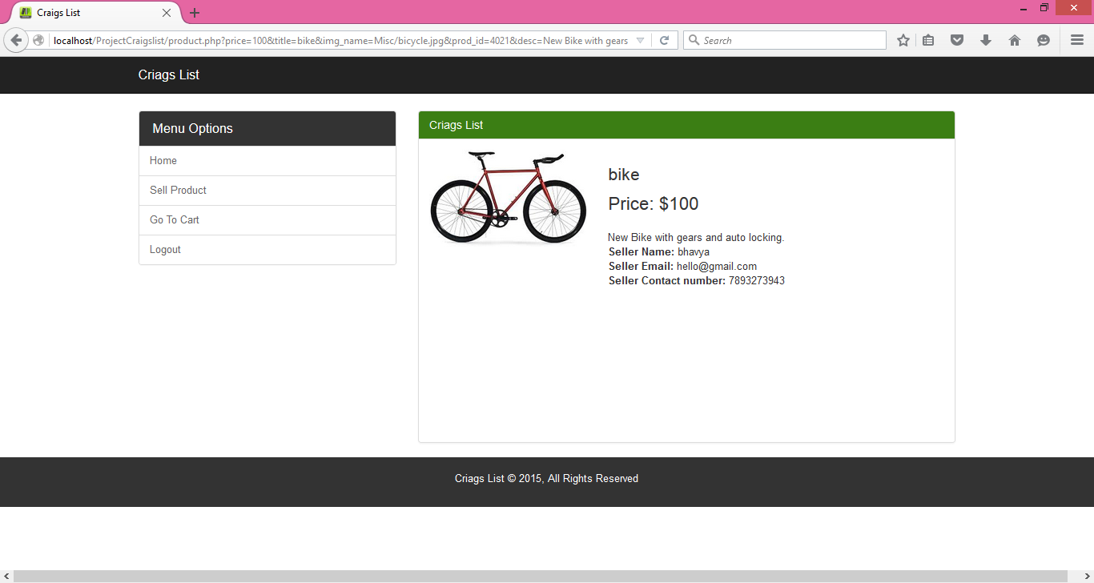

Go to Cart:

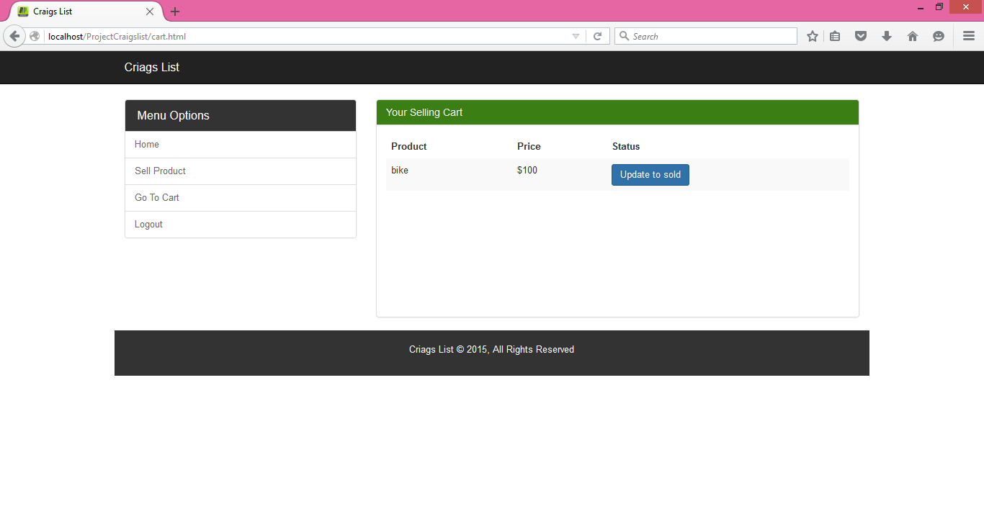

Updating Product to sold:

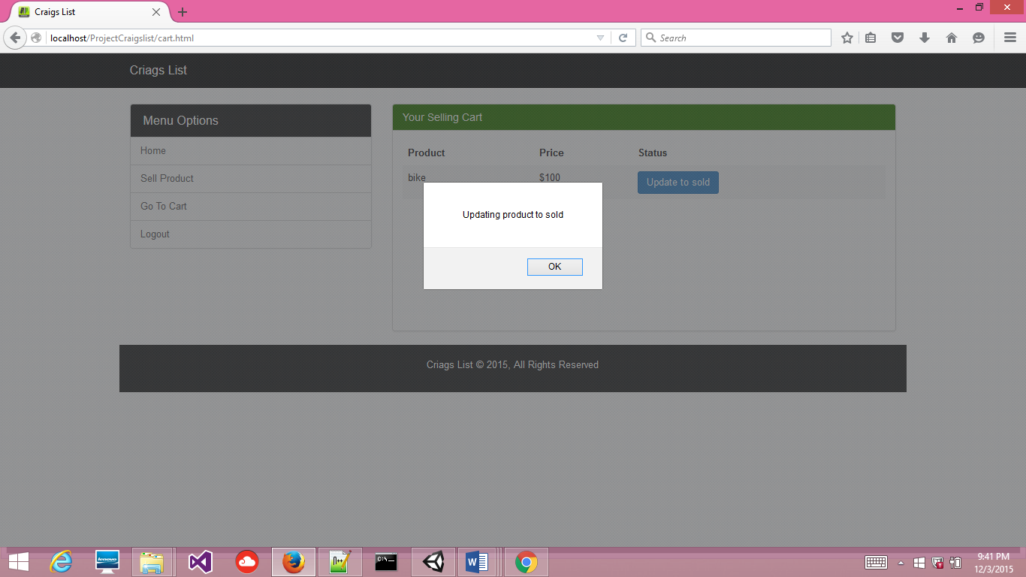

Cart Refreshed (Product history):

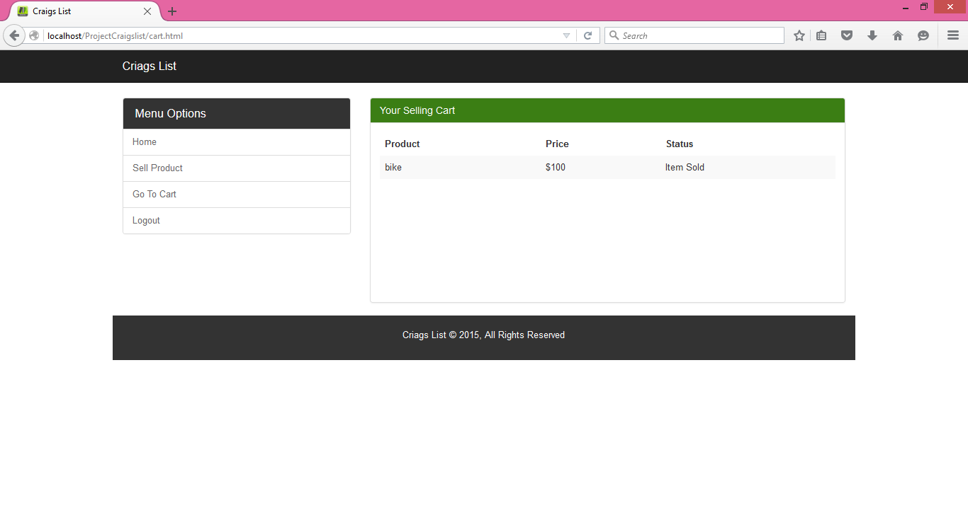

Product Listings Refreshed:

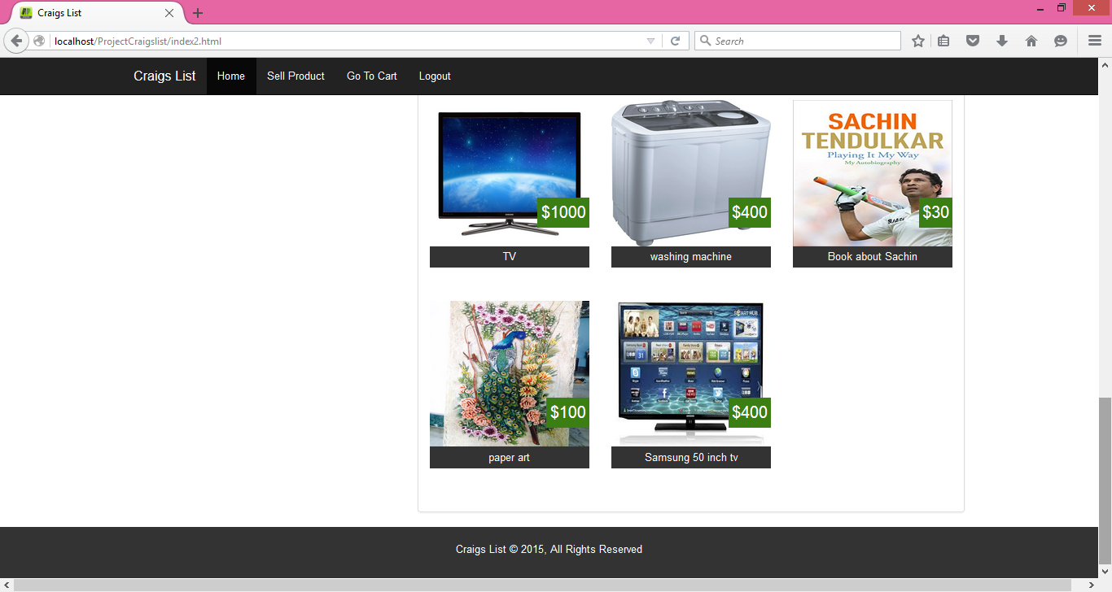

Logout:

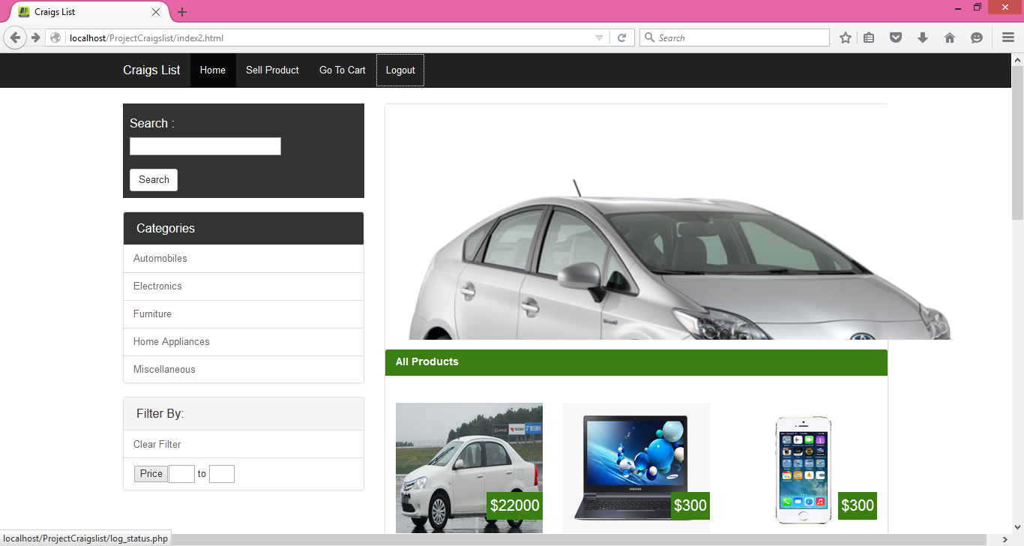

**Team Members and Work Division:**

**Swetha Maradana (sxm133730)**

Database Design(DB),

Product Listing(html,css,php),

Category Filter(html,css,php),

Search(html,css,php),

Price Filter(html,css,php),

**Ravali N(rxn152730)**

Database Design(DB),

Create Account(html,css,php),

Login(html,css,php),

Logout(html,php)

Main menu(html,css)

**Naga Bhavya Mandali(nxm144830)**

Database Creation(DB),

Sell Product(html,css,php),

Image Upload(html,css,php),

Go to Cart(html,css,php),

Update to sold(html,php)